**Project Design Phase-II**

**Data Flow Diagram**

|  |  |
| --- | --- |
| Date | 07 November 2022 |
| Team ID | PNT2022TMID10019 |
| Project Name | ANALYTICS FOR HOSPITALS’ HEALTH CARE DATA |
| Maximum Marks | 4 Marks |

**Data Flow Diagrams:**

A Data Flow Diagram (DFD) is a traditional visual representation of the information flows within a system. A neat and clear DFD can depict the right amount of the system requirement graphically. It shows how data enters and leaves the system, what changes the information, and where data is stored.

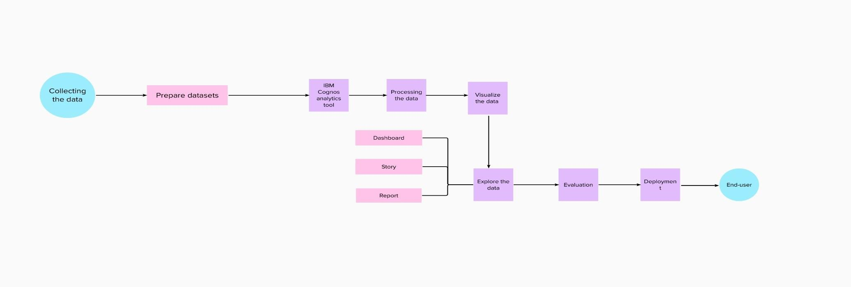

**User Stories**

Use the below template to list all the user stories for the product.

|  |  |  |  |  |  |  |
| --- | --- | --- | --- | --- | --- | --- |
| **User Type** | **Functional**  **Requirement**  **(Epic)** | **User Story Number** | **User Story / Task** | **Acceptance criteria** | **Priority** | **Release** |
| Customer (Web  user) |  | USN-1 | As a user, I can register for the application by entering my email, password, and confirming my password. | I can access my account / dashboard | High | Sprint-1 |
|  |  | USN-2 | As a user, I will receive confirmation email once I have registered for the application | I can receive confirmation email & click confirm | High | Sprint-1 |
|  |  | USN-3 | As a user, I can register for the application through Gmail | I can register & access the dashboard | Medium | Sprint-1 |
|  | Login | USN-4 | As a user, I can log into the application by entering email & password | I can access the dashboard | High | Sprint-1 |
|  | Dashboard | USN-5 | As a user, I can upload the datasets to the dashboard | I can access various operations | High | Sprint-1 |
|  | View | USN-6 | As a user, I can view the patient details | I can view the visual data and the result after the prediction | High | Sprint-2 |
| Admin | Analyse | USN-7 | As an admin, I will analyse the given dataset | I can analyse the dataset | High | Sprint-2 |
|  | Predict | USN-8 | As an admin, I will predict the length of stay | I can predict the length of stay | High | Sprint-2 |